QuickBooks for Windows
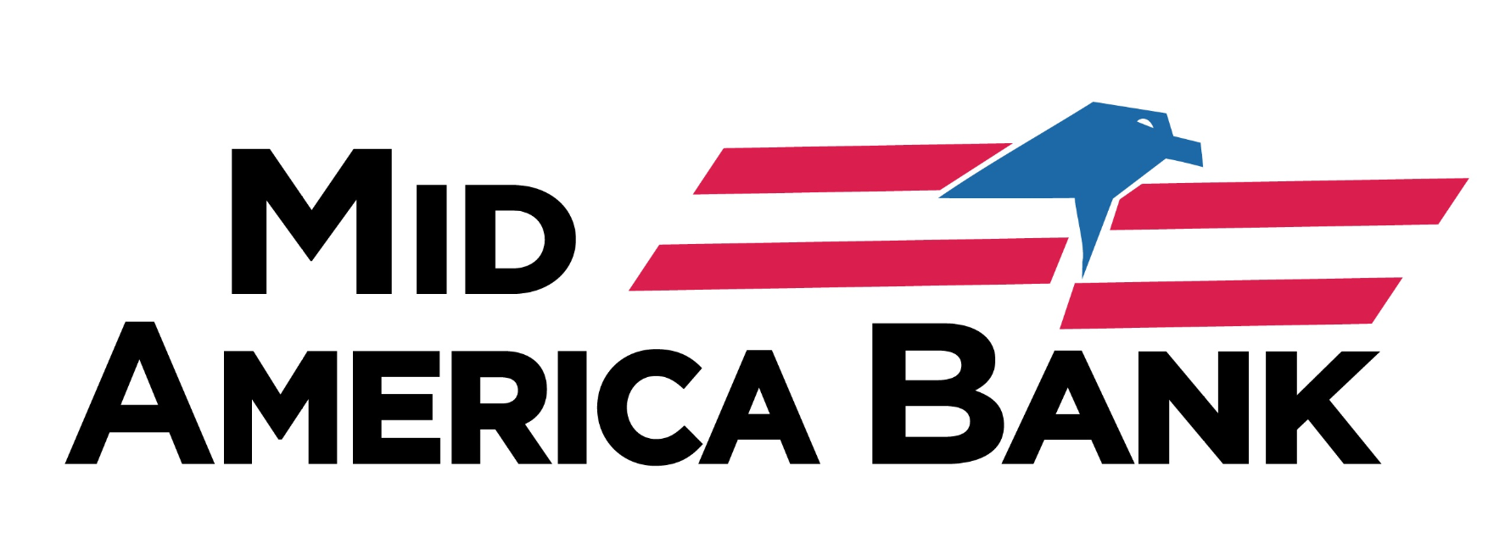

Conversion Instructions
  - Web Connect

Introduction
As Mid America Bank completes its system conversion, you will need to modify your QuickBooks settings to ensure the smooth transition of your data. Please reference the dates next to each task as this information is time sensitive.
To complete these instructions, you will need your login credentials for online banking.
You should perform the following instructions exactly as described and in the order presented. If you do not, your online banking connectivity may stop functioning properly. This conversion should take 15–30 minutes.
Thank you for making these important changes!

Documentation and Procedures
- Conversion Preparation
- Backup your data file. For instructions to back up your data file, choose Help menu > QuickBooks Help. Search for Back Up and follow the instructions.
- Download the latest QuickBooks Update. For instructions to download an update, choose Help menu > QuickBooks Help. Search for Update QuickBooks, then select Update QuickBooks and follow the instructions.
If multiple computers do not use the same QuickBooks data file, skip step 3. QuickBooks activities such as Online Banking cannot be performed in multi-user mode because of the way the activities interact with a company data file.
- Switch to single user mode. For instructions to switch to single user mode, choose Help menu > QuickBooks Help. Search for Switch to Single User Mode and follow the instructions.
If you are not using Classic Mode (Register Mode), enable it for the conversion. You can change it back after the conversion is complete.
- Enable Classic Mode (Register Mode).
- For instructions to enable Classic Mode (Register Mode), choose Help menu > QuickBooks Help. Search for Banking Feed Modes, select Bank Feeds Modes overview, scroll down, and follow the instructions.
- Disconnect Accounts in QuickBooks on or after 8/12/2019
- Choose the Lists menu > Chart of Accounts.
- Select the account you want to deactivate.
- Click Edit menu > Edit Account.
- Click on the Bank Feed Settings tab in the Edit Account window.
- Select Deactivate All Online Services and click Save & Close.
- Click OK for any dialog boxes that may appear with the deactivation.
- Repeat steps for each account to be disconnected.
- Reconnect Accounts to Mid America Bank on or after 8/12/2019
- Log in to https://www.midambk.com/ and download your QuickBooks Web Connect file.
- Click File > Utilities > Import > Web Connect Files.
Take note of the date you last had a successful connection. If you have overlapping dates in the web-connect process, you may end up with duplicate transactions.
- If prompted for connectivity type, select Web Connect.
- Click the Import new transactions now radio button, then click OK.
If you previously removed the check from the “Always give me the option of saving to a file...” option, then this dialog will not display.
- In the Select Bank Account dialog, click Use an existing QuickBooks account.
- In the corresponding drop-down list, select your QuickBooks account, and click Continue.
- Confirm the prompt by clicking OK.
- Repeat steps for each account to be reconnected.
Verify that all transactions downloaded successfully into your account registers.
- Re-enable Express Mode (if necessary)
If you prefer Classic Mode (Register Mode), you are finished with your conversion. If you use Express Mode for online banking, you may now re-enable the mode.
For instructions to enable Express Mode, choose Help > QuickBooks Help. Search for Banking Feed Modes, then select Bank Feed Modes overview, and follow the instructions.

